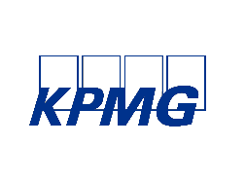

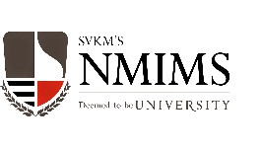
Knowledge Partner

Registration Form

I / we would like to attend / nominate the following:

Delegate 1

Name

Designation

Organisation

Participation - Both the Days / Day 1 or Day 2

Address

City and PIN

Tel # Mobile # Email

Delegate 2

Name

Designation

Organisation

Participation - Both the Days / Day 1 or Day 2

Address

City and PIN

Tel # Mobile # Email

Delegate 3

Name

Designation

Organisation

Participation - Both the Days / Day 1 or Day 2

Address

City and PIN

Tel # Mobile # Email

Please add a separate page for details of more nominations

Registration Fees

Participants will have to invest in the following manner

Rs. 3,000 per delegate for both the days,

b. Rs 2,000 per delegate for one day.

Service Tax will be applicable @ 14.5%.

10% early bird discount is available till 25th February 2016. Again 15% discount will be given for three to four nominations and 20% for five and above nominations, in addition to the early bird discussion.

Method of Payment

Cheque or Demand Draft is to be issued in favour of SVKM’s NMIMS

For ECS the following details me please be used

Bank and Branch: CITI Bank, Mumbai Branch

IFSC Code: CITI0100000

MICR: 400037002

Account Type and No.: Current Account No. 0710653011

Cancellation of the nomination should be done seven days in advance of the event. If advance intimation is not made for the same, registration fee is applicable and paid / borne by the company or individual.

Fee once paid is not refundable, although change of nomination is allowed. The registration fee includes lunch, refreshments and conference kits.

Prior Registration is essential. Please courier/email the registration form at the earliest.

____________________________________________ _____________________________

(Name & Designation of Nominating Authority) (Signature)

Note: Methods of Sending Registration Details

Kindly send the scanned filled registration form to sbm.conference@mnims.edu along with details of payments through NEFT. Please State in the Subject line ‘REGISTRATION for ‘NMIM Business School – Industry Conference;

Physical copies of forms along with the cheque for payment to the following address:

Ms. Nikita Ghadigaonkar

Room No. 822, Eastern Side

NMIMS School of Business Management

V. L. Mehta Road, Vile Parle (West)

Mumbai – 400101

Phone No. 022 4235 5707

